**Tableau Deployment**

To visualize our report we’re using Tableau Public, It is a free platform to explore, create, and publicly share data visualizations online. Visualizations that have been published to Tableau Public (“vizzes”) can be embedded into web pages and blogs, they can be shared via social media or email, and they can be made available for download and exploration by other users.

Based on our text mining and statistical analysis we’re developed an comparison dashboard using Tableau Public and was deployed in Tableau web server.

|  |  |  |  |
| --- | --- | --- | --- |
| S.no | Layout type | Count | Feature description |
| 1 | Card | 4 | Highlighted key values in terms of Tamil Nadu election, 2021. |
| 2 | Geographical Tamil Nadu map | 3 | Comparative Tamil Nadu map Assembly constituency by district. 2011, 2016, and 2021 election were plotted. |
| 3 | Interactive legends | 1 | Party & Alliance legends. |
| 4 | Highlight filters | 1 | Highlight search filter for picking selected district-wise comparison. |
| 5 | Table | 1 | Raw data which table contains all the raw records. |

[**DISTRICT-WISE ASSEMBLY CONSTITURNCY COMPARISON MAP, DASHBOARD**](https://public.tableau.com/views/DistrictMap_16195883861090/StatsMap?:language=en&:display_count=y&:origin=viz_share_link)

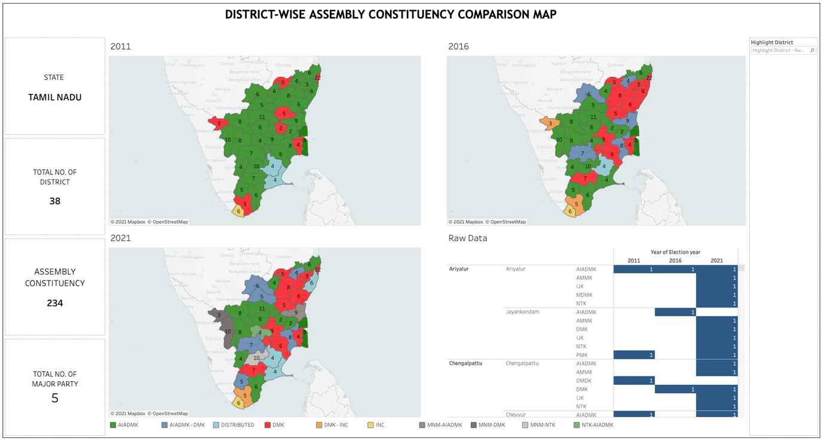

**Figure n,**

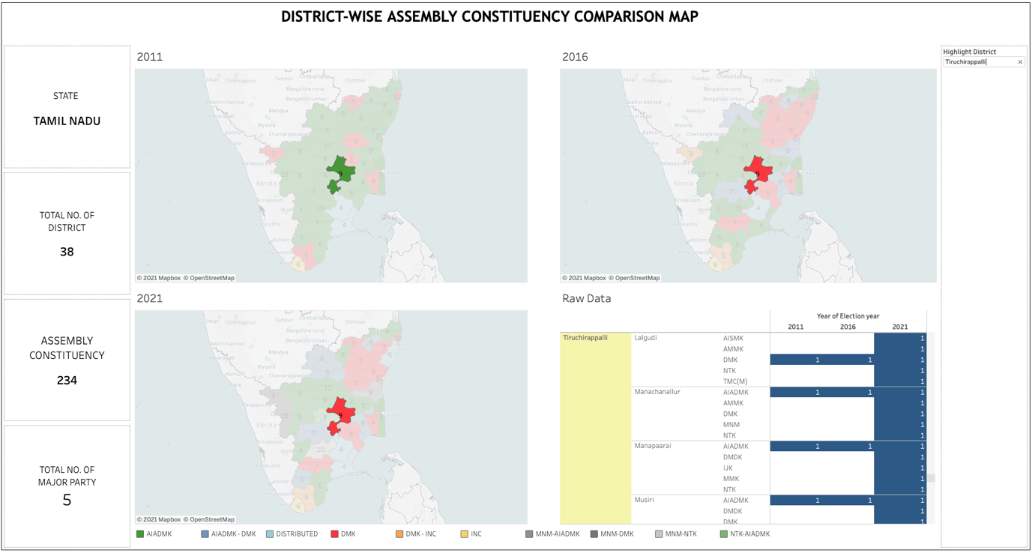

**Figure n,** Highlight search filter

Above Figure , Highlight search filter is used to toggle between different district-wise comparison on Party and alliance over the period of 2011, 2016, and 2021. 38 individual district was provided as the option in the search field, where user can select any one district at a time for comparison.

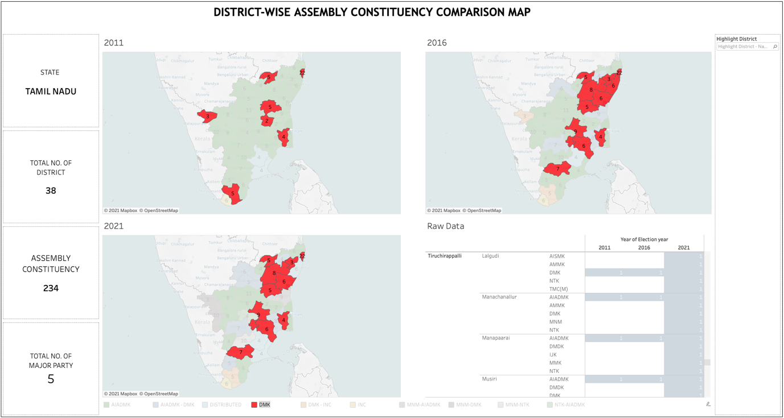

**Figure n, Interactive** Party & Alliance legends.

Above Figure , **Interactive** Party & Alliance legends is used to toggle between different Party -wise comparison on the map over the period of 2011, 2016, and 2021. where user can select any one Party & Alliance at a time of comparison.